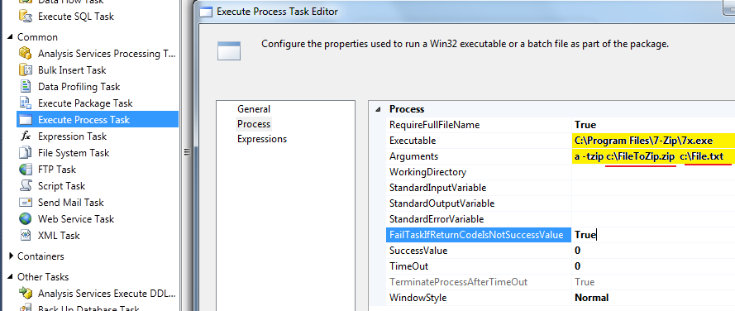

Executable: C:\Program Files\7-Zip\7x.exe

Arguments: a -tzip c:\FileToZip.zip c:\File.txt